Name of Student: Aniruddha Pratap Singh | PRN:25070122247
Semester: III | Year : AY 2026-27
Subject: Programming with Java
ASSIGNMENT No : 2
TITLE : Constructors in Java
Problem Statement
Develop a Java application demonstrating the use of default, parameterized, and copy constructors for object initialization and data management.
Learning Objectives

To understand and implement default, parameterized, and copy constructors for object initialization.

Programme:
class Student {
int roll;
String name;

Student() {
roll = 0;
name = "NA";
}

Student(int roll, String name) {
this.roll = roll;
this.name = name;
}

Student(Student s) {
this.roll = s.roll;
this.name = s.name;
}

void show() {
System.out.println(roll + " " + name);
}
}

public class StudentApp {
public static void main(String args[]) {
Student s1 = new Student();

Student s2 = new Student(247, "Aniruddha");

Student s3 = new Student(s2);

s1.show();
s2.show();
s3.show();
}
}

Output:
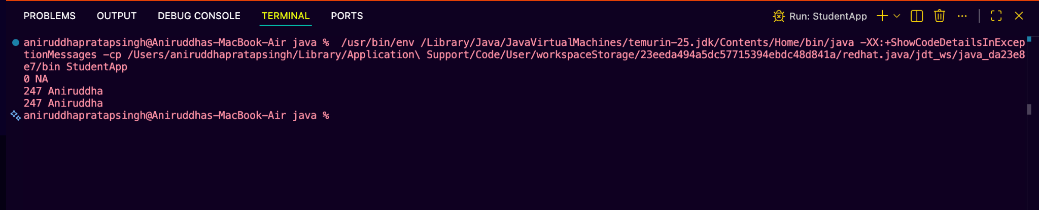

Conclusion:
This code successfully shows three ways to set up data in Java:
- Default Constructor: Acts like a blank template, giving a student starting values when we don't have their details yet.
- Parameterized Constructor: Lets us plug in specific details (like roll number and name) the moment we create the student.
- Copy Constructor: Works like a photocopy machine. It makes a brand new student that looks exactly like another one, keeping the data safe and separate.

